

**INDUSTRIAL CUM SOFTWARE TRAINING REPORT**

**SUBMITTED IN PARTIAL FULFILLMENT OF THE DEGREE**

**OF**

**BACHELOR OF TECHNOLOGY**

**IN**

**COMPUTER SCIENCE ENGINEERING SUBMITTED BY:**

**NAME:AMANDEEP & GURPREET**

**ROLL NUMBER:1707638 &1707669**

**Under the Guidance of:**

**Faculty Mentor Name:Snehlata bharmoria**

**Designation: Mentor**

**Department: Web Development**

**Organization: Impinge Solution**

**GULZAR GROUP OF INSTITUTES, LUDHIANA, PUNJAB**



**[BTCS-802] INDUSTRIAL & SOFTWARE TRAINING**

**TRAINING REPORT**

**UNDERTAKEN AT**

**“IMPINGE SOLUTION, MOHALI”**

**8 FEB to 8 JULY, 2021**

**ON**

**“TEMPLATE HUB”**

**SUBMITTED IN PARTIAL FULFILLMENT OF THE DEGREE**

**OF**

**BACHELOR OF TECHNOLOGY**

**IN**

**COMPUTER SCIENCE ENGINEERING**

**SUBMITTED BY**

**NAME: AMANDEEP & GURPREET AND ROLL NO: 1707638 & 1707669**

**Under the Guidance of:**

# Mentor Name:Snehlata bharmoria Industry Supervisor:Gurman kaur Designation: Mentor Designation: Campus Recruiter Department: Web Development Department: Training & Placement

**GULZAR GROUP OF INSTITUTES, LUDHIANA, PUNJAB**

**DECLARATION**

I hereby declare that the project work entitled (“ Template Hub”) is an authentic record of my own work carried out at (Mohali) as requirements of four months Industrial Training for the award of degree of B.Tech (CSE), Gulzar Group of Institutes, Ludhiana, under the guidance of (Mrs.Gurman Kaur) and (Mrs.Snehlata Bharmoria), during (8 Feb ) to (8 July), 2021.

I hereby declared that the above statement made by me is correct to the best of our knowledge and belief.

(Signature of student)

Name of Student: Amandeep & Gurpreet

University Roll Number: 1707638 & 1707669

Date: 7 June,2021

**ACKNOWLEDGEMENT**

The success and final outcome of this project required a lot of guidance. First and foremost, we would like to thank God for giving us courage to bring up this project. At the outset, we would like to propose a word of thanks to our worthy teachers for providing us the facilities and encouraging us at every moment.

Also, I would also like to thank all the faculty members in our department and students of my class for their support and suggestions.

We would also like to express a deep sense of gratitude and thanks profusely to **Ms. Snehlata Bhamoria Director/Impinge Solution** of company. Without his wise counselling and able guidance, it would have been impossible to complete the project in this manner.

Last but not the least, we wish to avail ourselves for this opportunity, express a sense of gratitude to our parents who helped us in finishing our project with their support, love and for everything.

**Date:**7june,2021 Amandeep & Gurpreet

**Table of Content**

1.Introduction……………………………………………………………………………………………3-4

2. Application Environment………………………………………………………………………5

3. Functional Description………………………………………………………………………6-20

4. Issues & Concerns………………………………………………………………………………….21.

5. Other Requirements…………………………………………………………………………21-24

6. reference………………………………………………………………………………………………..25

# 1.Introduction

## 1.1 Application Overview, Scope & Objectives

Shablony is a hub for variety of website templates .We offer Web templates,their installation, hosting and customization all these services you can always get at Shablony.com. If you're thirsty for knowledge, Shablony blog provides you with the most recent web design news, infographics, freebies, discounts & promos.Never doubt that a group of talented designers and developers who love doing beautiful things together can change the online world.

We have been in business for over a decade, and from the very start Shablony has reconsidered how a website gets done through a professional web template. Yes, you can pull off building a site on your own. But we know how to do website design which is powerful enough to get you started, and we can always be within your budget. We give you an affordable template, optimized for SEO and speed performance, and it offers you a vantage of controlling the content, look and functionality of your website. That means you can edit most of it on your own.

Shablony team is now an awesome core group of experienced people using everything they have learned to help you build amazing websites the right way.

## 1.2 Purpose of the Document

The purpose of this document is to layout in detail the functional and other requirements. This document contains the necessary information to meet the requirements set forth for the completion of this project. The target audience of this document is Project Sponsor, Project Managers, Developers, Designers, and QA Engineers. Now onwards, this document will act as a portal of information during the whole development cycle and any change in the functional or other requirements will be communicated through this document.

## 1.3 Vision / Views of the Technology Head / Project Sponsor

Vision here is to develop a professional, result-oriented web application & present the client’s application as the leading solution of this type in the industry.

## 

## 1.4 Definitions, Acronyms and Abbreviations

Shablony is a hub for variety of website templates .We offer Web templates,their installation, hosting and customization all these services you can always get at Shablony.com. Shablony blog provides you with the most recent web design news, infographics, freebies, discounts & promos.Never doubt that a group of talented designers and developers who love doing beautiful things together can change the online world.

Shablony team is now an awesome core group of experienced people using everything they have learned to help you build amazing websites the right way.

# 2. Application Environment

## 2.1 Technology Environment

## 

**2.1.1 Hardware**

|  |  |  |
| --- | --- | --- |
| Hardware Environment (Deployment Server) | |  |
| PC | Windows Server |
| Processor | Intel Pentium Processor 4, 2.4GHz or above. |
| RAM | 1 GB RAM |
| HDD | 120 GB |

|  |  |  |
| --- | --- | --- |
| Hardware Environment (End user’s PC) | |  |
| PC | PC (Windows), Apple, Linux |
| Processor | Intel Pentium Processor, 233 MHz or equivalent. |
| RAM | 512 MB RAM |
| HDD | 500 MB of free HDD space for Internet Cache |
| Internet Connection | 512K |

**2.1.2Software**

|  |  |  |
| --- | --- | --- |
| Software Environment (Deployment Server) | |  |
| Operating System | Windows Server |
| Other software | Php,Mysql(WAMP) |
| Web Server | IIS 7.0 or above |
| Browser | IE8+,Mozilla Firefox, Google Chrome |

**2.2 Security System**

* Restricted access to admin section.
* Restricted access to member/groups section.

## 2.3 External Interfaces

### Hardware Interface

* None

### Communication Interface

* None

### User Interface

* None

# 3. Functional Description

**1. Sign In& Sign Up Process:**

The user will have an option to register through social media sites and simple registration process. The welcome mail will be sent to the provided Email Id. It will be first level for joining the website. On Clicking of the Join Shablony.com the user will be directed to profile creation page.

**2. Range of template price options**Each product is available with several price options. You can choose Single Site, Developer’s or Buyout License depending on the goals you pursue. You can additionally order installation or hosting services.

**3. Template customization services** If you are not skilled in editing a template on your own, you can order customization services and we will change the content, color scheme, implement your logo and make other tweaks for you

**4. All source files included** Getting a standard HTML template, CMS based theme, eCommerce web design or any other template from Shablony, you get all the source files within a template download package.

**5. Free licensed stock photos** We provide a range of 7-15 licensed stock photos with each template for free life-time usage within a particular template. So you get quality hi-res photos which are in tune with a theme category

Let millions discover how you do it

We’d love to hear your story. Send us answers to the questions below,  
and you might find yourself appearing on Shablony Stories! Remember, your story   
is someone else's inspiration, even if you never thought about it that way.  
  
When we post a story, we always link back to the author’s website and promote the story on our social channels, which means you will definitely get increased exposure.

**My name \***

**My Shablonywebsite \***

**My email \***

**Tell us about yourself and your business**

**What do you find most gratifying about your work?**

**How did you first learn about TemplateMart?**

**How / to what extend did your business grow after using TemplateMart?**

**Please send a photo of yourself(preferable size: 300px width x 188px height)**

**Dashboard for** Shablony.com**:**The User dashboard will show the user stats and template history and itemized details of your purchase.

**Why Shablony.com:** The member can select as per the goal to visit Shablony.com.

**Twitter feeds on profile page:** The member can show twitter feeds from the twitter account by providing the name.

#### Links to sites and blogs:

Google+, Facebook, Twitter & Pinterest

Add buttons to your site so visitors can share your site and follow you on social sites. Easily adjust the size and style of button you’d like on your site.

Social feed

Add a social bar to your website so visitors can find your Facebook, Twitter and Google+ links all in one place.

**Manage Your Newsletters:** The member can also set the newsletter and messages sending setting through the following options

**About Shablonycom:** The Master Admin will have the right to manage the content for the Shablonycom site detail.

## FAQ:The user can manage and update the FAQ for the website content.

* **View All FAQ**

**Terms and condition:**The master admin can set the Terms and conditions and will be editable for future.

**Privacy Policy**:The master admin can set the Privacy policy and will be editable for future.

**Press Release**: The Press release details can be added to the website.

**Upload Videos:**The videos will be uploaded to simplify the users experience in dealing with the website.It can range from a wide variety how to make a good design to tips for professional website,user experience videos.

**News letter:**The newsletters can be uploaded category wise

**Premium Template Listing:**The **Template** will be listed on the premium business listing. The company will have higher privileges and will be on the top of the search criteria and will be shown in top featured companies. A Company can also be directly get listed

**Offers:** The offers will be posted to the website by the admin time to time. These offers can be availed by the company for publicity. A provision will be given to admin to post the offers on the member profile

**Promotion Code:**  The promotion codes will be sent to the members. The user can avail the code and can be listed on the website

## 3.2 Additional Features:

**1. Search:** The search criteria will be on the basis of Name,Category or Location.

**2. Advertisement:**The google add sense will be integrated and users can also post advertisements online or with the help of RSS feeds.

**3. Email Shablony.com Customer Service:**The visitor can write to the Shablony.com for any kind of services.

**3.3 Administrator Section**

**1.Manage Users**

In this section Admin can view online users, view their profiles on their profile pages and could also edit their photo gallery. Admin can also activate/deactivate the member’s account at any time, change and reset their profile. The password of user will not be viewable to any of the admin. User can change their password through a change password system provided to them.

.

**2.Ask the Expert feature**

Under this section Admin have privileges to assign this features to general laymen user, registered users and registered paid users. Basically this portion is divided into two parts the expert and the trainer. The expert will be able to see the various questions posted to him and the trainer will to see the various questions posted in his mentored group and can reply to particular question thereafter and set its status to be displayed or not. Expert/ Trainer will also be able to see the questions posted to other expert/trainer by searching based on particular criteria like trainer/expert name, group name, date range etc. with their replies (if given) but will not be able to post their replies. Whereas SuperAdmin has all sort of privileges. Admin could view the various questions posted to experts and can reply the answers to verified questions. Admin can also set status for various questions which are going to display on the user section.

**3.Manage Content**

The various static pages like Help etc feature will be managed through a CMS editor in this module.

**4.Manage Events**

In this section admin can add/modify and activate/deactivate events according to specific date. There is event calendar which will help to track the list of events added by admin. The admin is able to see list of members that are coming and those that are not coming i.e RSVP features is enabled. The admin can also decide whether to generate an RSVP for a particular event or not and could also specify the number of guest allowed for an event. He can also generate a newsletter for an event and can send it to all registered members to inform about an event.

**5.Create and Send Newsletters**

In this section admin can create/send newsletters based on particular categories with the help of an editor. Admin could also search for newsletters by giving parameters like date of creation and category. The newsletter can be send to only those users who have subscribed for the newsletter. The admin can also charge the users subscribed for this feature if needed.

For this we have subscription categories. User can select from these categories to which newsletter he/she wants to subscribe for.

There will be 3-4 kinds of newsletters. For example

1) General newsletter

2) Promotions from third parties/partners newsletters

**6.Manage Premuim Templates**

In this section admin can add/modify/delete various **Templates** under a particular paid category.

**7.Manage free Templates**

In this section admin can add/modify/delete various **Templates** under a particular free category.

**8.Manage Blogs**

Admin can view blog of any user and delete comments as well blog entries.

**9.Manage Categories**

Admin can view categories of any templates and delete /update and add categories.

**10.Manage SubCategories**

Admin can view categories of any templates and delete /update and add categories.

Admin Screenshots:

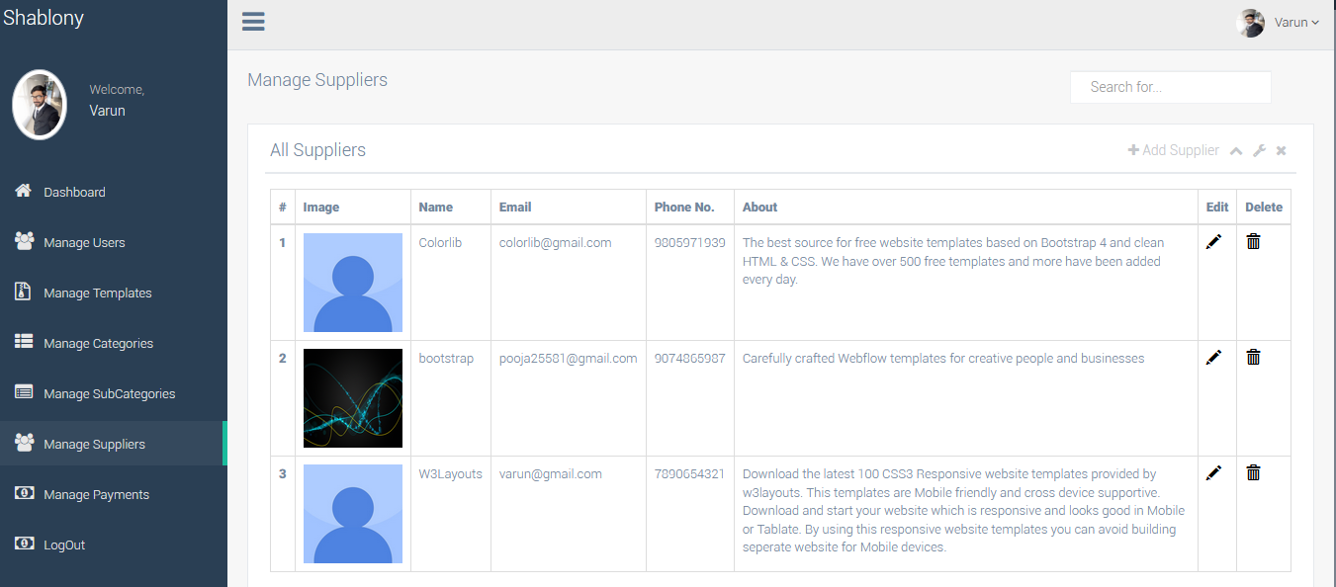

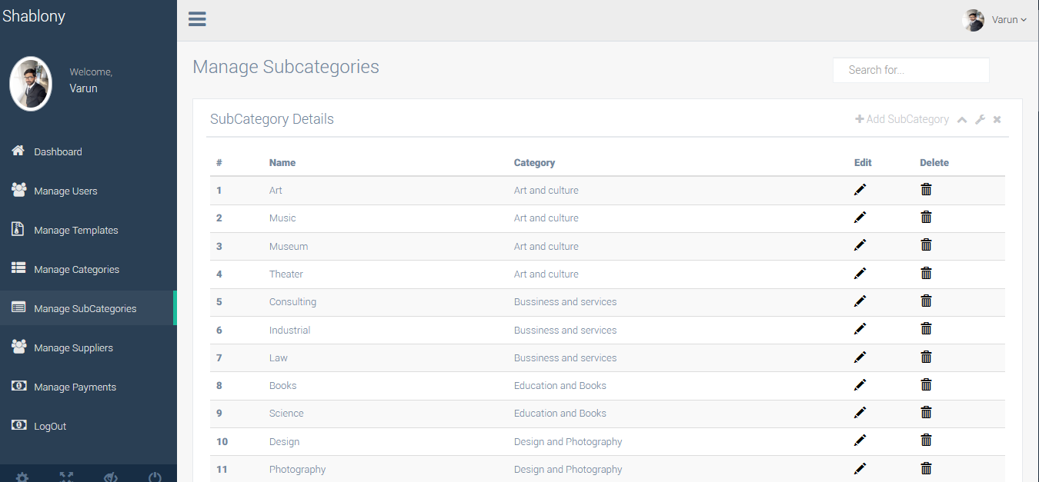

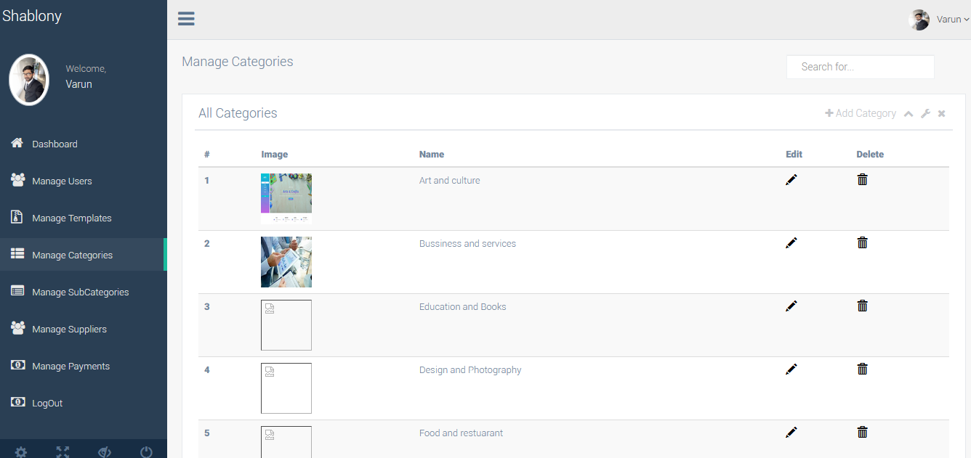

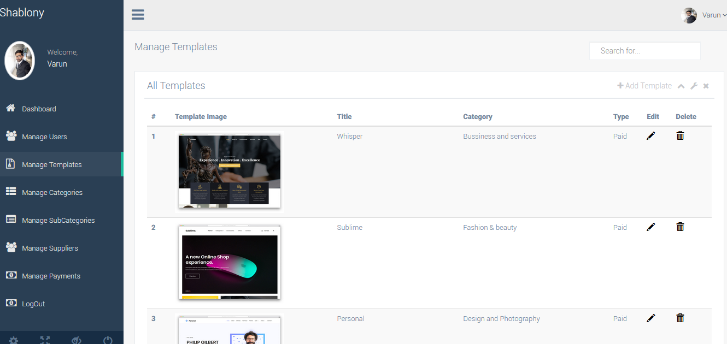

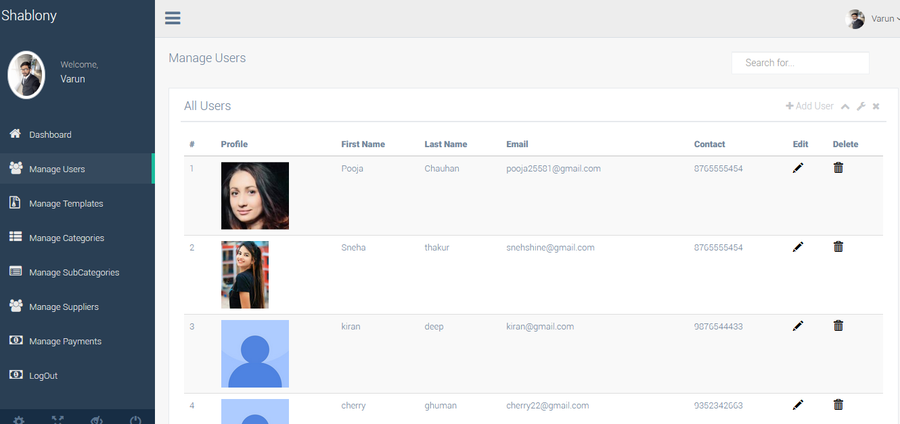

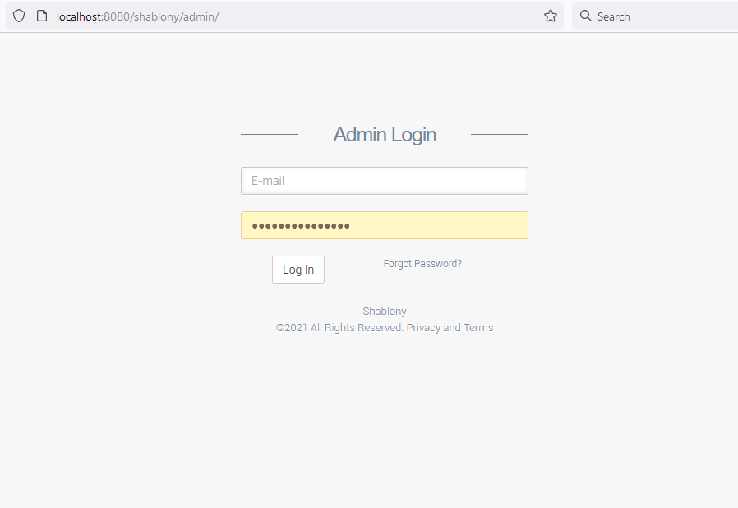

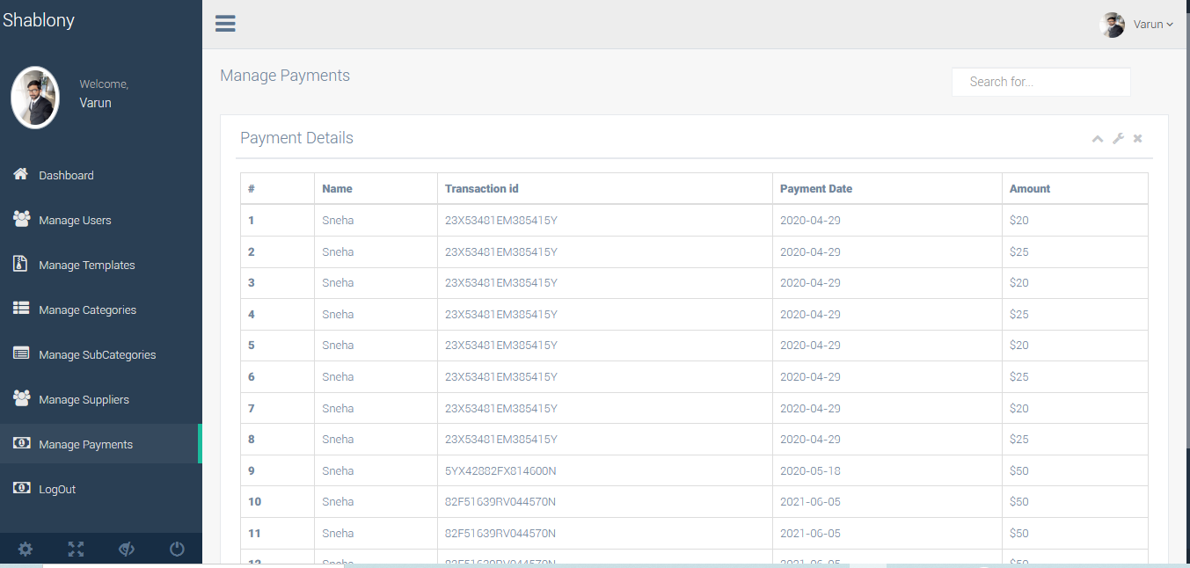

# 3.1 Functional Description

**1. Sign In& Sign Up Process:**

The user will have an option to register through social media sites and simple registration process. The welcome mail will be sent to the provided Email Id. It will be first level for joining the website. On Clicking of the Join Shablony.com the user will be directed to profile creation page.

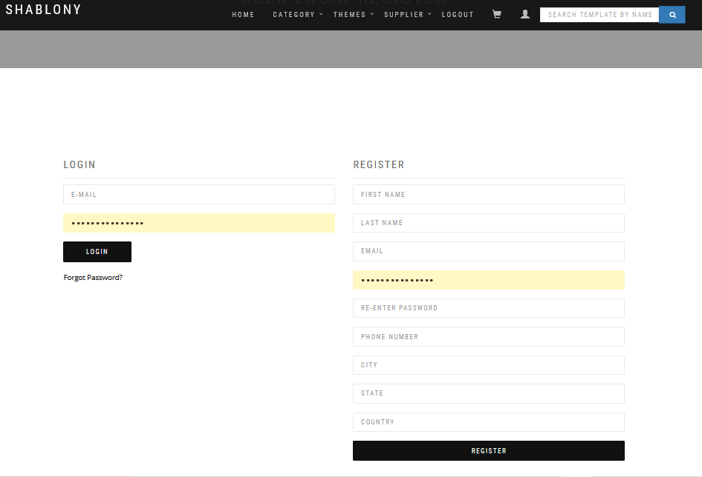

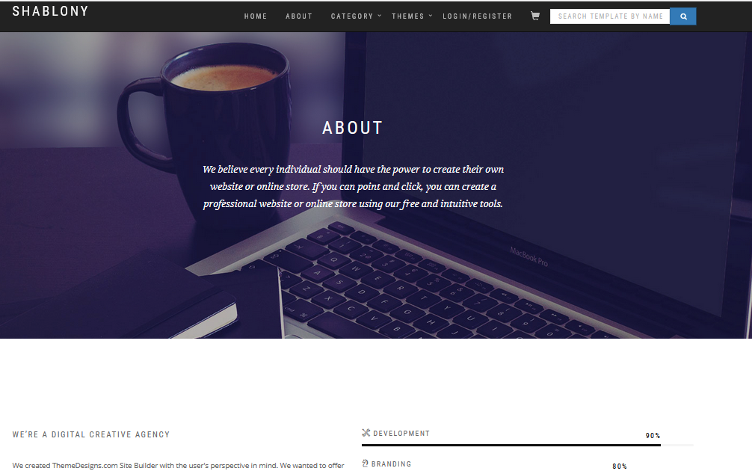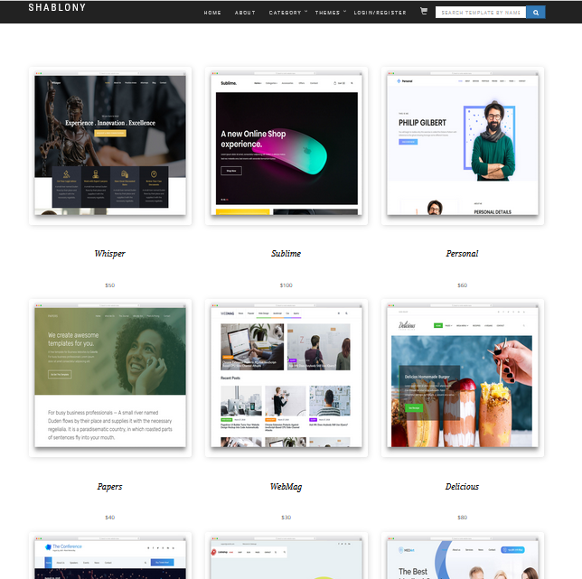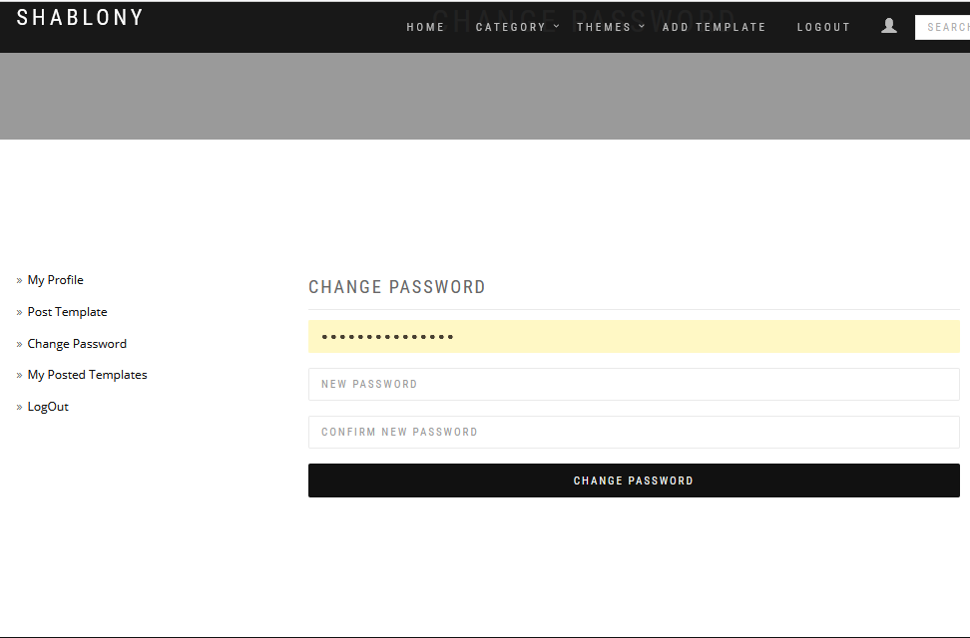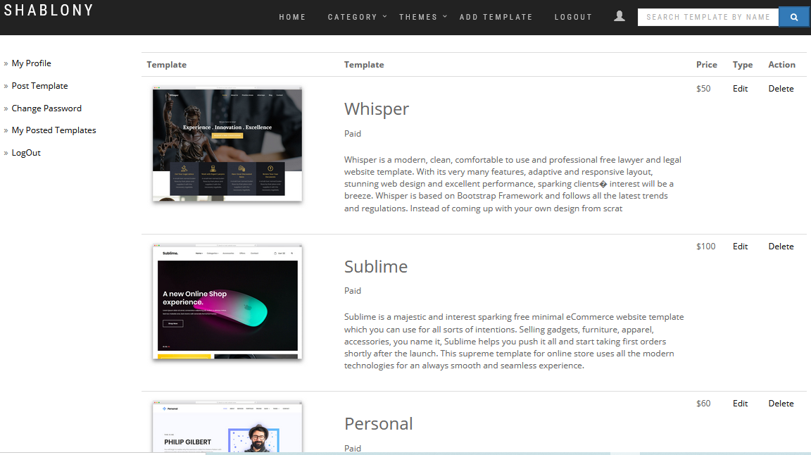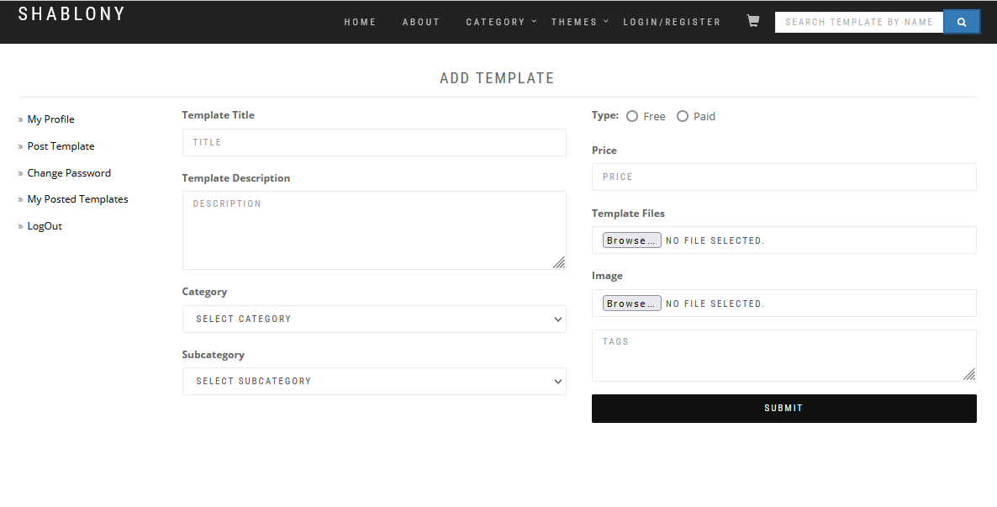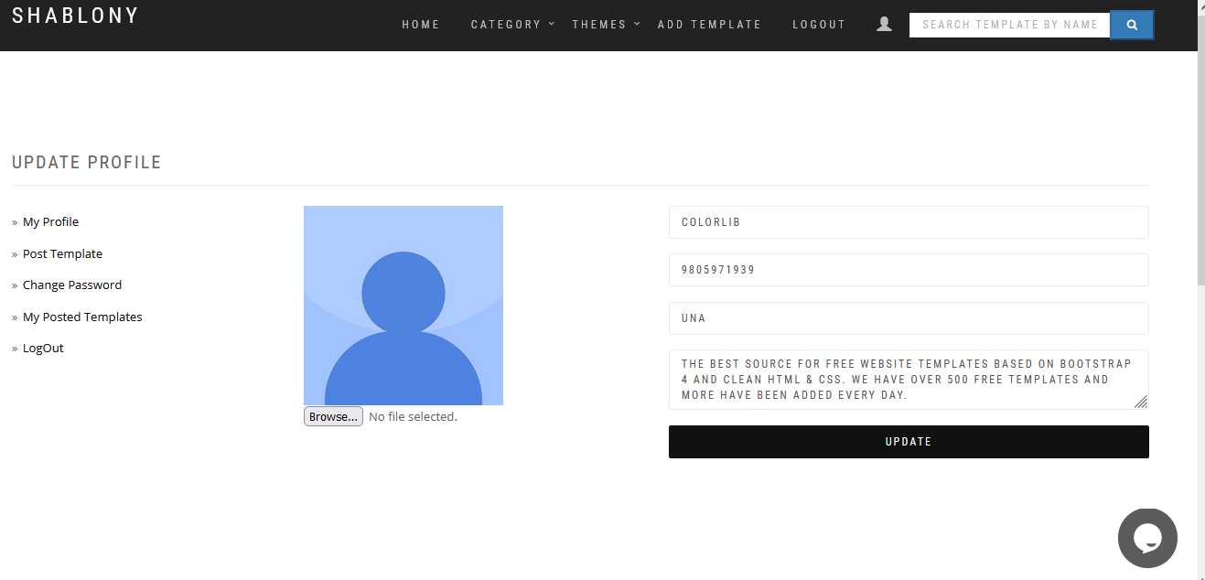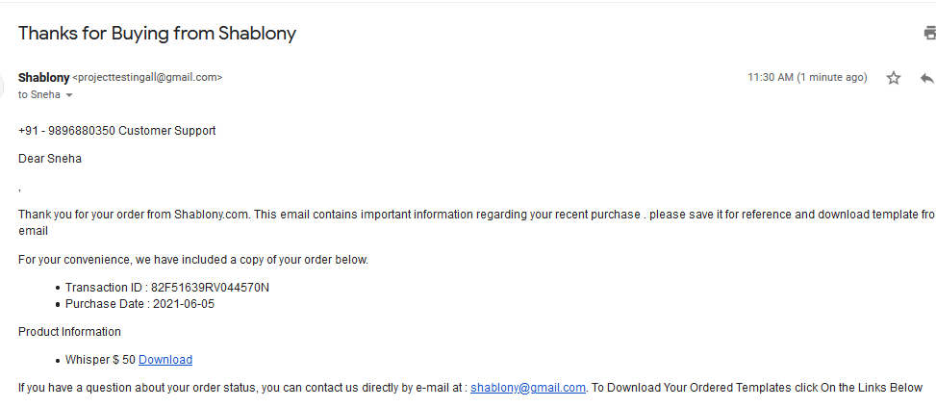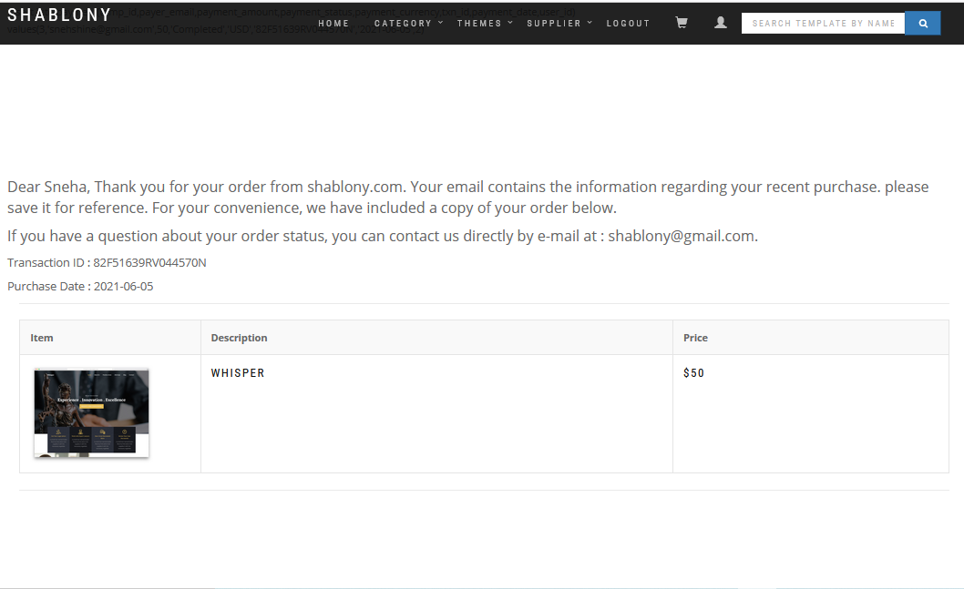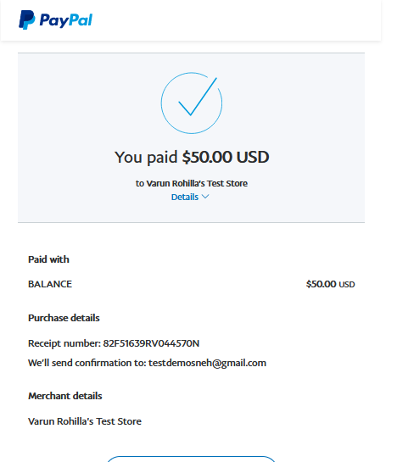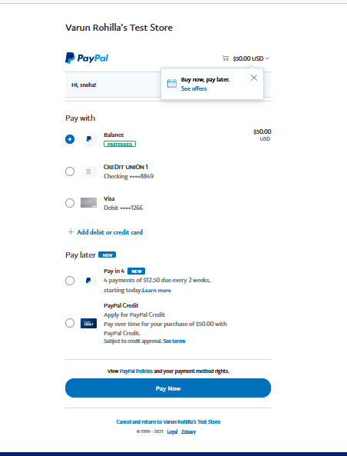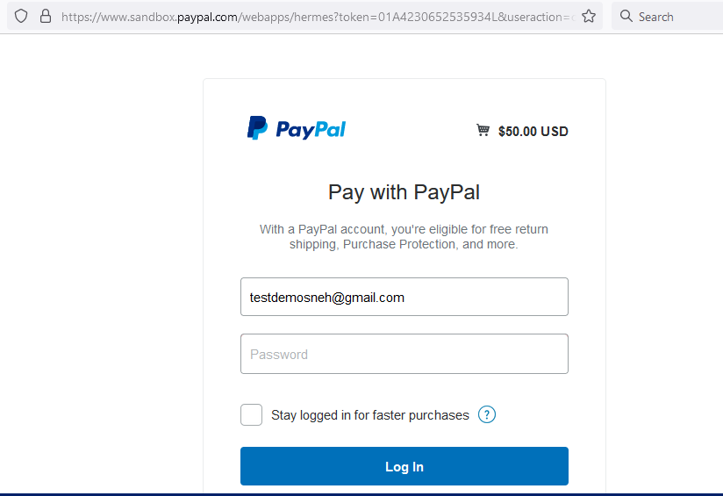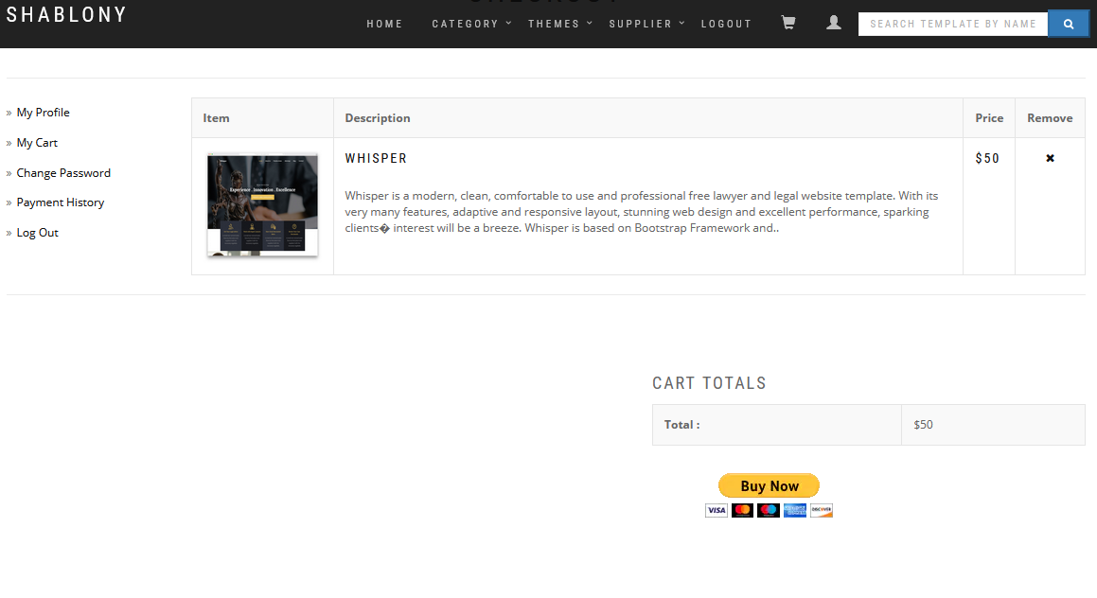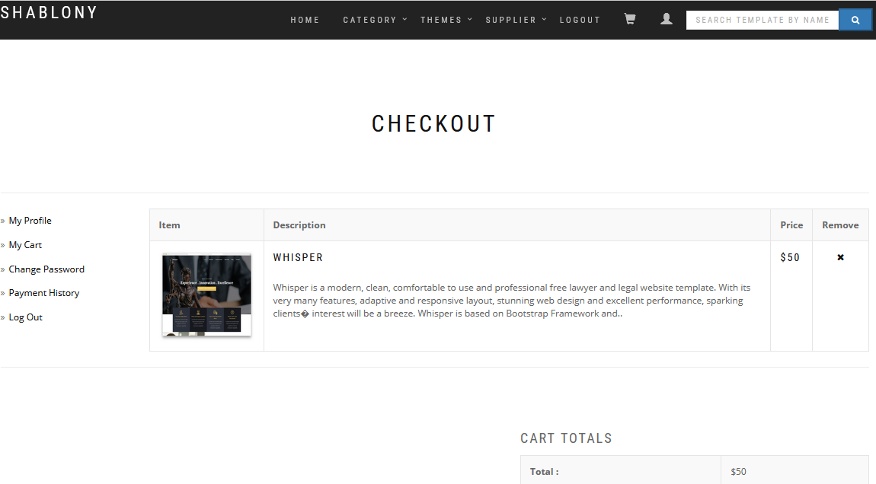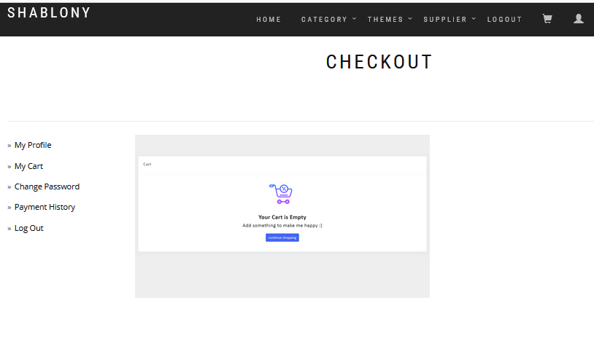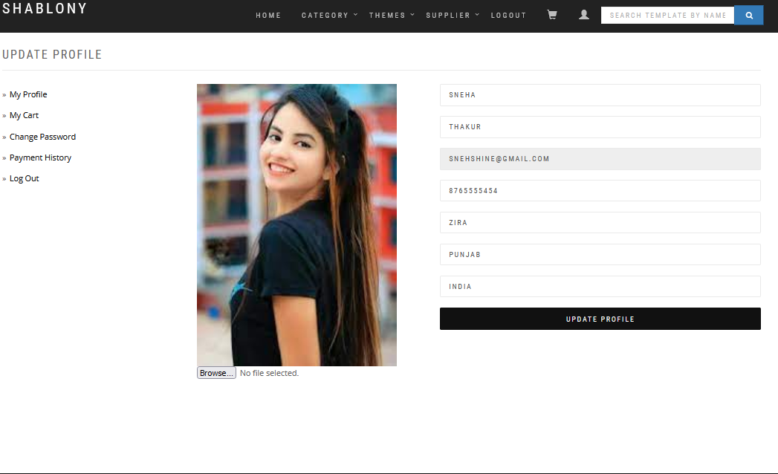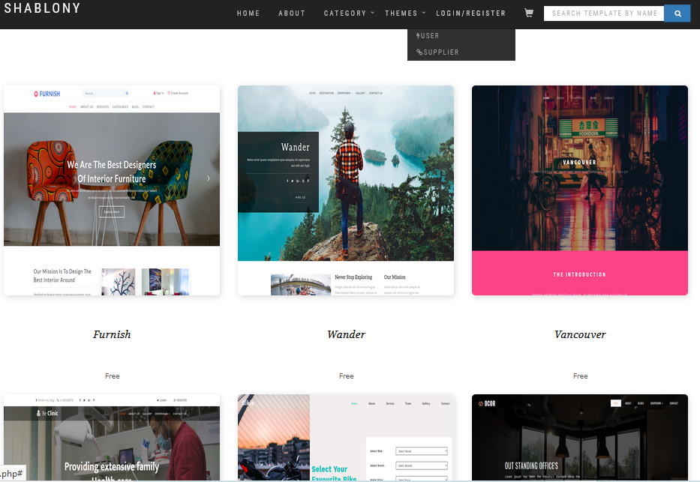

**2. Range of template price options**Each product is available with several price options. You can choose Single Site, Developer’s or Buyout License depending on the goals you pursue. You can additionally order installation or hosting services.

**3. Template customization services** If you are not skilled in editing a template on your own, you can order customization services and we will change the content, color scheme, implement your logo and make other tweaks for you

**4. All source files included** Getting a standard HTML template, CMS based theme, eCommerce web design or any other template from Shablony, you get all the source files within a template download package.

**5. Free licensed stock photos** We provide a range of 7-15 licensed stock photos with each template for free life-time usage within a particular template. So you get quality hi-res photos which are in tune with a theme category

**6. Free sample templates** On our website you can find free samples to download and learn skills in working with any product type, before actually buying the product which might be the best fit for you

**7. Special offers and personalization** We can personalize your purchase with a special offer or deal. This can be a designer’s bundle, some training course, hackers and spam protection pack, copyright protection service, or SEO boost offer.

**8. Clear guidance on your purchase** We can guide you in choosing a theme that is the best fit for your site. Also we will let you know where to go and what to do should something happen out of the ordinary or in case you have questions.

[Blog](http://blog.templatemonster.com/)**s**deserves of its own attention. The sheer variety of web design topics is impressive. To get an idea, look through the main categories, hit some popular tags, top it off with a line of infographics and free web design stuff. The reading and viewing is sure to go down smooth.

* **Search Downloaded Products from below criteria**
* Top of Form
* Date Range
* Item Number
* Product Type
* Transaction ID
* **Search Payments**
* Date Range
* Order ID
* Transaction ID:
* Order Status:Approved,All,Awaiting Approval,Cancelled,Not Processed ,Pending

**9. Shopping cart:**The member will have an option to buy online . The user can buy templates and add to his cart and will be directed to payment screen

The purchaser will be directed to the following page after adding the purchased lists to the cart

On clicking Proceed to Check out the following page will appear for payements

**10. Bills and Orders:**Users can get the details of all the payments and orders done on Shablonycom

**11. Products and Specifications Tab:** The User can add its products and Specifications as many as the template choosen.All the necessary technical specifications regarding the template should be provided**.**

**12. User Profile Page:**

The following page will have the user details like name, location, address, City details. User can also set the public setting and the hide the details from public view



**13. Edit User Information:**The user can edit the information as needed.

**14. Recommend Website:** The user can recommend the website, these recommendations will be public.

**15. About Us:**Short and detailed description about the Shablony.com



**16. Business Categories:** The Items can be listed under the category as provided in the Shablony.com list. The content will be listed as per the category selected.

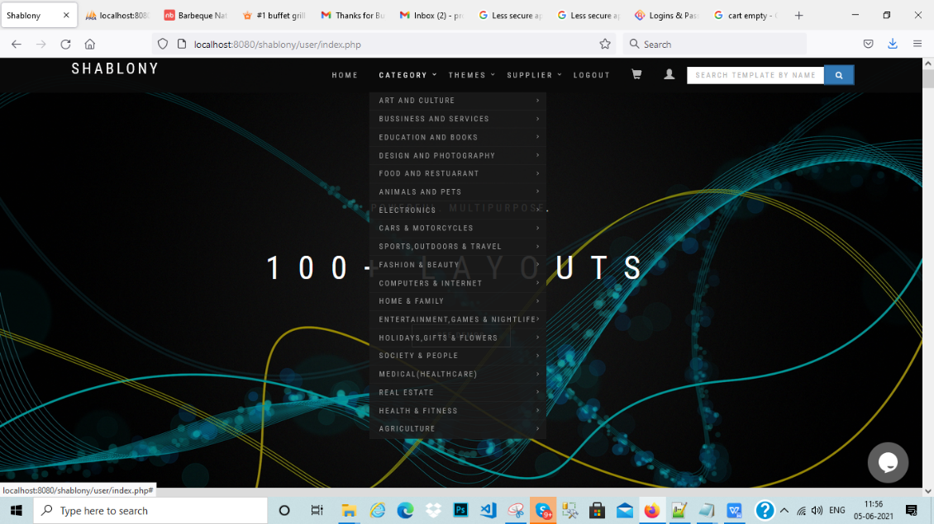

**17. Business SubCategories:** The Items can be listed under the category as provided in the Shablony.com list. The content will be listed as per the category selected.

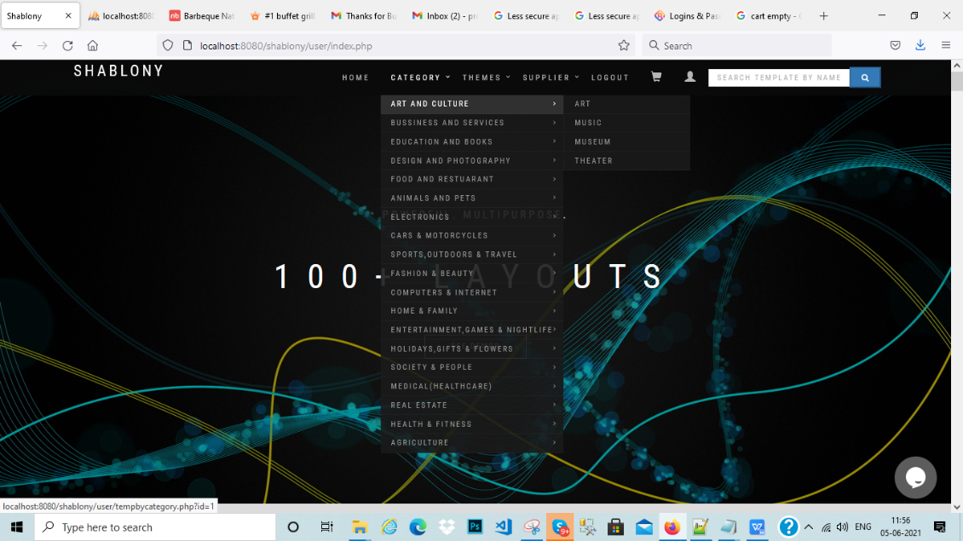

**18. Business Information:** Shablony.com can add the business information and its details, specifying the number of users, revenue, location and about the organization.

**19. Map Tab:** On clicking of Map Tab the google map will appear as per the location specified in the filed

**20. Add Events:** The admin can upload information about events occur within Shablony.com Network with other professionals and Shablony experts at fun and exciting events User **Meetups** which Boost your business

###### **Get the tools & tips to launch & manage your business online Grow Your Business**

#### through Workshops ,Art Exhibits ,Event Sponsorship

**21. View All Events:** The user can edit the events with the following option.

## 22. HIRE A FREELANCE DESIGNER( Paid Service):We empower people like you to create your own online presence for free and exactly the way you want

Our powerful technology makes it simple for everyone to get online with a beautiful, professional and functional web presence. No creative limits, no coding – just  
complete freedom to express yourself and manage your entire business online. Our global user base, open SDK, and unparalleled design capabilities create  
a unique ecosystem. Partners, developers, web designers, and other online  
professionals can effectively market their Apps and services to millions through Shablony

**3.1 Share Your Story**

**11.Manage SecurityQuestions**

Admin can view categories of any templates and delete /update and add security questions.

**12.Manage Free Stuff (Like Coupons)**

Admin will be able to give the name, description, upload picture and points range for a particular free gift to be given to the user. He will also be able to search the gift by giving the name and/or points for a particular thing and can take actions like edit/delete thereafter.

**13.Manage Roles**

Admin can manage any type of role he wants (Agent, Expert etc) by selecting the role and checking out the type of privileges to be assigned to that role.

**14.Manage Permissions**

Admin would be provided the functionality where he will be able to manage the access for the free users. The various permissions provided will be as listed below.

**15.Manage News**

This module will only be visible to super admin. Here the admin could select the domain name entered in database with cities and mention the RSS link there, to display the news on that domain.

**16.Manage Cities**

Super admin would be provided a module where he is asked to post cities, their zip codes and the domain name related to that city. These cities will then be used on the site for tasks such as user registration, diet store posting etc.

**Advertisement Module**

Advertisement module for different states (and cities) and the banner ads will be uploaded by the agents in those cities. These ads will be of in format .jpg and .gif. Users can view ratesand then contact the agent and make the payment offline. It will be rotating banner ads.

Admin will be provided a module where he can post the rates for the ads display on predefined particular areas of the page. These rates will then be displayed to user as specified above.

**Ads Classifieds**

Add classified with local as well as national listings. Any user who is uploading the ads in the local region will also be added in national classified ads .

Admin will be provided a module where he can create the categories and sub categories for the classifieds required.

For the categories and sub – categories posted by admin, registered users will be able to post ads under them by giving

* Title
* Description
* Image
* City
* State

# 4. Other Requirements

# 4.1 Issues & Concerns

No issue

## 4.2 Database Layouts

4.2.1 All tables

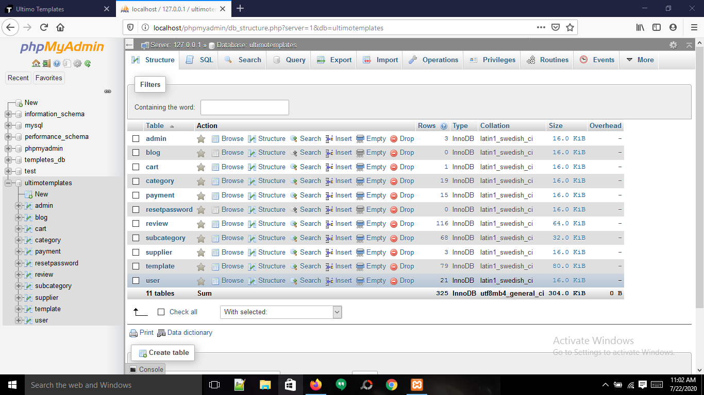

4.2.2 Payment

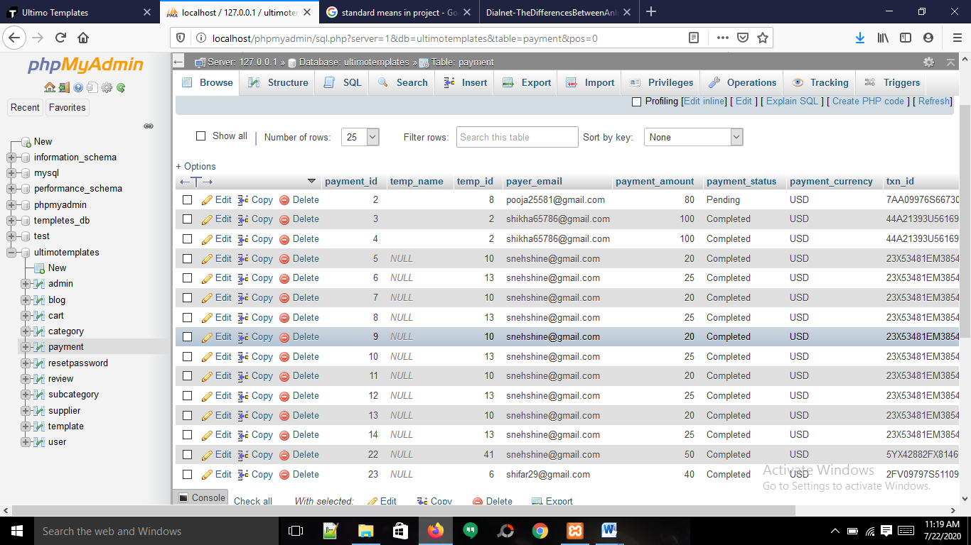

4.2.3 User

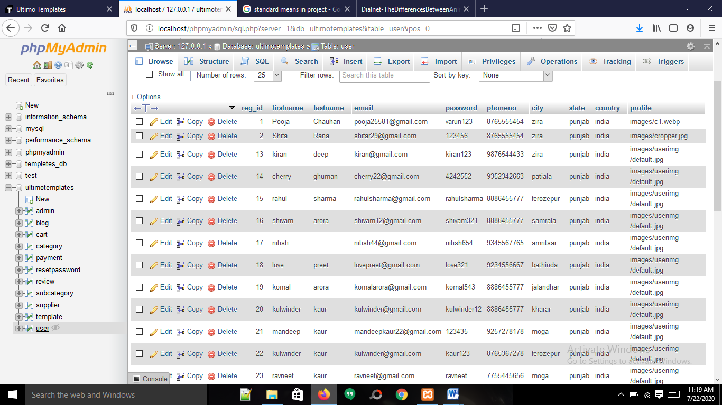

4.2.4 Supplier

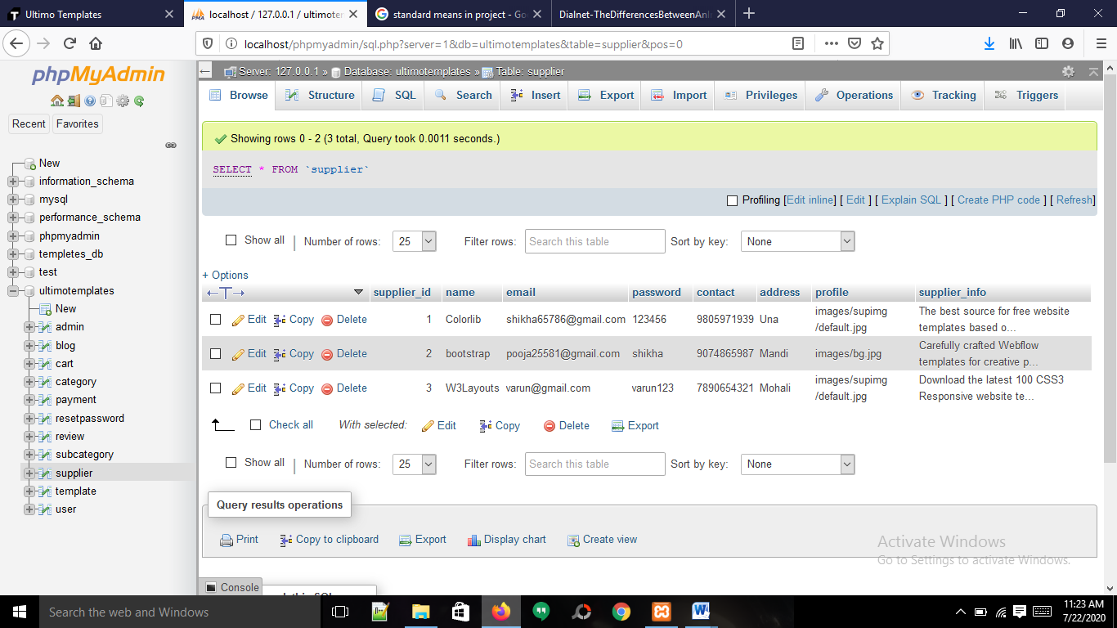

4.2.5 Category

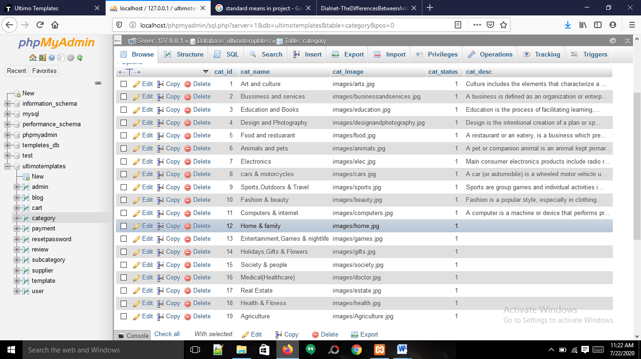

4.2.6 Subcategory

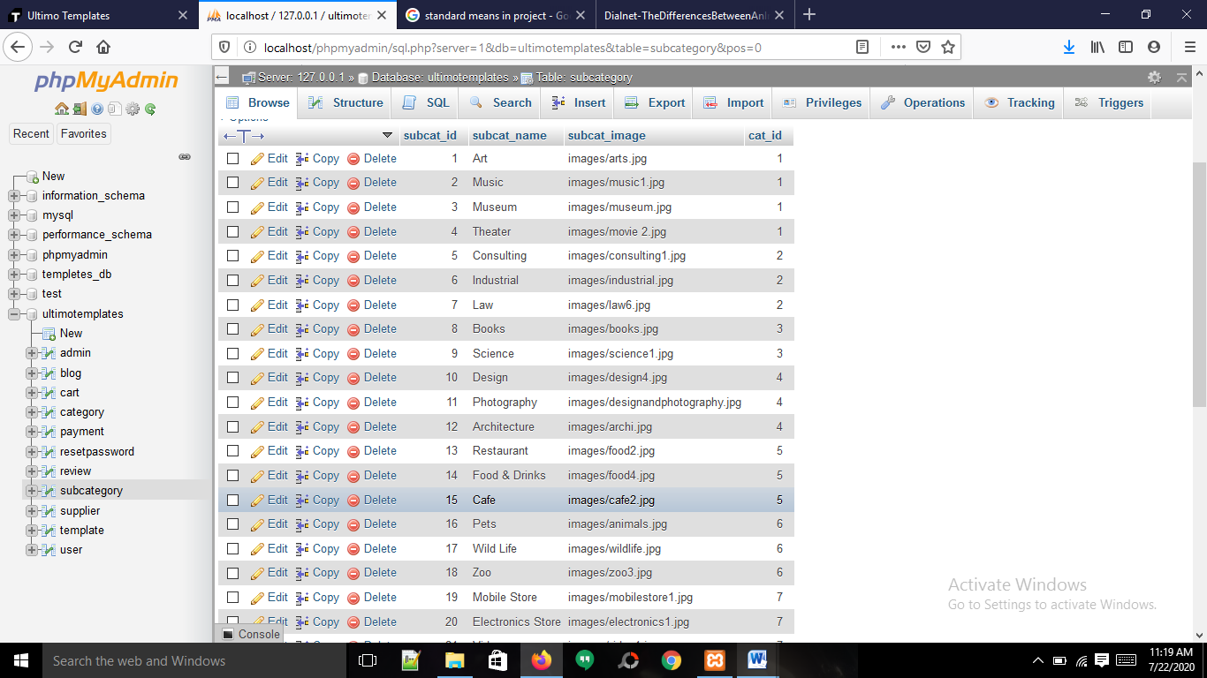

4.2.7 Template

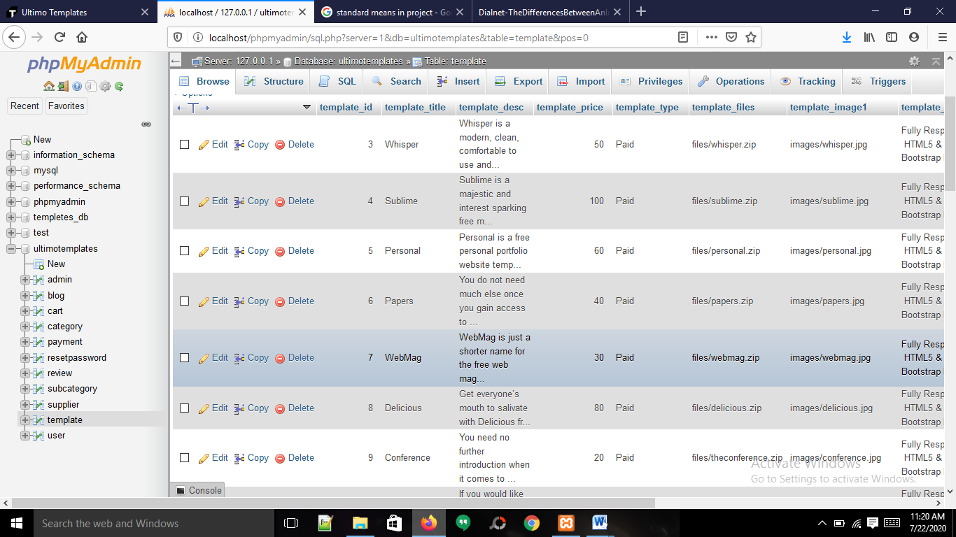

4.2.7 Review

## 

## 4.3 Input Forms Formats

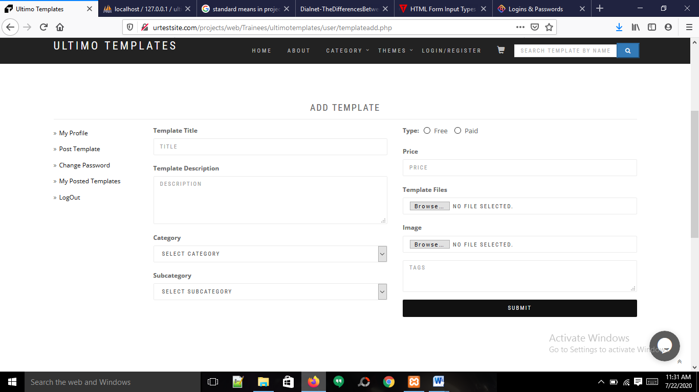

**6. Reference**

* Project Specifications
* Templatemonster.com
* www.jqueryrain.com

## Chapter 4

### 16. References

1. [Qickr.com](http://www.manta.com/)
2. Olx.in
3. Project Specifications